Question3

FNU Anirudh

October 29, 2015

# Question 3 (10.5 Problem Set D)  
r<- c(0.693,0.662,0.690,0.606,0.570,0.749,0.672,0.628,0.609,0.844,0.654,  
 0.615,0.668,0.601,0.576,0.670,0.606,0.611,0.553,0.933)  
z=log(r)  
plot(density(r))

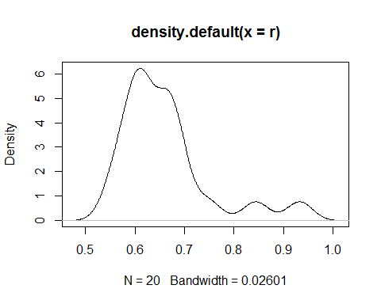

plot(density(z))

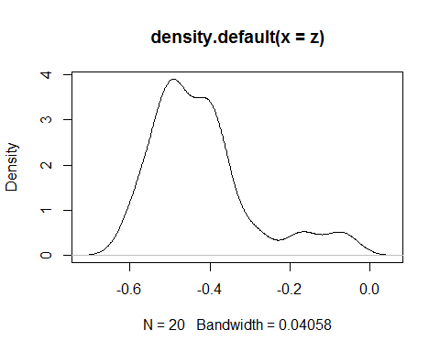

boxplot(r,z,horizontal = TRUE,main="Box Plots")

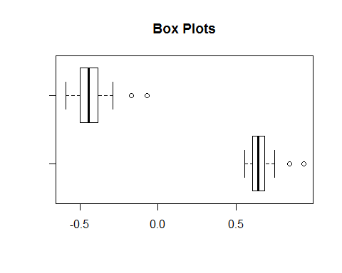

s=IQR(r)/sqrt(var(r))  
s

## [1] 0.7620725

t=IQR(z)/sqrt(var(z))  
t

## [1] 0.8544223

# 1)Both the ratios and the log of the ratios are very similar when tested  
# for normality but log of ratios behave like normal distribution. This can  
# be easily seen by looking at the density plot or boxplot. In all the   
# cases the log of the ratios is slightly better with respect to normal  
# distribution i.e. more shifted to right, In General Density plot of  
# ratios has two bumps where as Density plot of log of ratios has only one  
# and after looking at IQR to Stdev ratio we can say that log of ratios  
# is closer to what we expect to be normal deviation.  
#______________________________________________________________________  
# 2) I would use the log of the ratios for which an assumption of   
# normality seems more plausible. Therefore the mean we would like to test  
# now is   
log(0.618034)

## [1] -0.4812118

# For the hypothesis testing, from the point of view of the anthropologist  
# would be:  
# H0 : µ = ???0.4812. vs. H1 : µ!= ???0.4812  
# One could argue that the anthropologist wants to minimize Type I error,  
# i.e., that the Shoshoni civilization actually used golden rectangles   
# but the test shows otherwise. This is why in the test H0 represent  
# the golden ratio.  
# TO Calculate the Student's 1-sample t-test ,we need mean  
m=mean(z)  
m

## [1] -0.4230678

st= sqrt(var(z))  
st

## [1] 0.1287264

tn= (m+0.4812)/(st/sqrt(20))  
tn

## [1] 2.019596

# p = 2 ??? pt(???2.02, df = 19) = 0.05771 > 0.05 = ?? ??? fail to reject H0  
y<- sort(r)  
# 3) To build a confidence interval with confidence 0.90, the following   
# needs to hold: 1????? = 0.90 =??? ??/2 = 0.05  
k=qbinom(0.05, 20, 0.5)  
# By Experimentation  
1- pbinom(k,20,0.5)

## [1] 0.9423409

# We can construct a confidence interval of 94% which is very close to  
# 95% and any other choice would be way off the value.  
# The form of interval is (sorting the values) :   
# (x(k+1), x(n-k))= (x7, x14)  
y[7]

## [1] 0.609

y[14]

## [1] 0.67

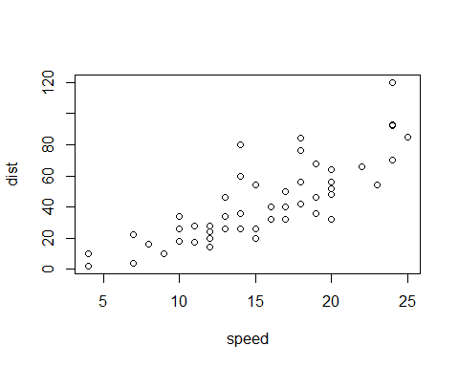

Note that the echo = FALSE parameter was added to the code chunk to prevent printing of the R code that generated the plot.